**Engineering Notebook**

**Team 16 – Clear Path**

Cannon Newbury

**09/12/2024** - Team 16s first meeting and talk with customer, Dr. Towhidnejad. Scrumwise and Github established to start adding backlog and documentation for the project. Division of skills between team members like Scrum-Master, Software, Hardware, and documentation. Stand-up meeting to discuss the proposed objectives from customer and first steps taken.

**09/24/2024** - Teams first day in LB 131 with the flight simulator. Below is some of the information we gathered.

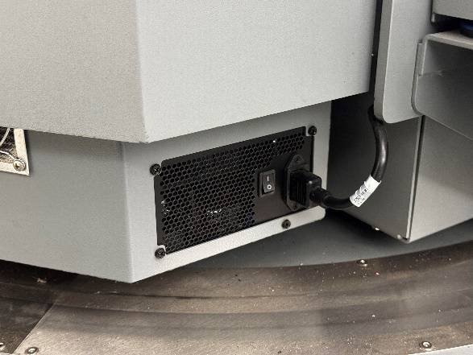

The white switch turns on the whole rig, and the smaller switch on the right side is now to turn the PC on.

There is a small red button below the seat on the right side, click the button one time for the green light to illuminate. Finally plug a wired keyboard into the hub on the right picture, follow the prompts on the screen and get to the home screen. From there we can use the wireless keyboard with mouse built in to navigate. We also uploaded any relevant text documents into our GitHub (<https://github.com/SadeedKhan555/ClearPath>).

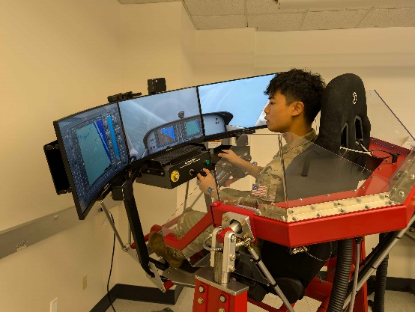

We got some time in on the simulator to see the different function, and displays within X-Plane.

10/15/2024 - Replacing Emergency stop button, part was ordered a week in advance install was slowed due to hurricane and campus closure. Images for button install are below. In addition, the peer reviews were completed by team members along with the sprint review presentation.

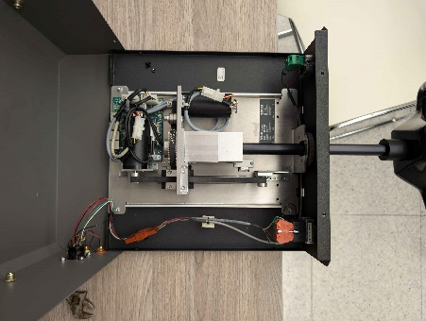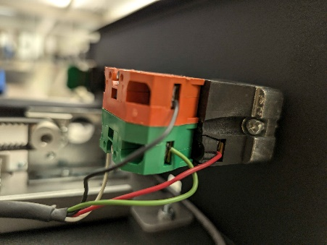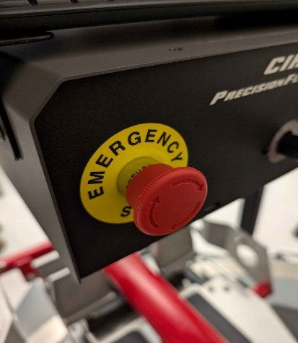

10/22/2024 - United Briefing; No work done

10/24/24 – Team meeting with student previously in charge of flight sim to ask questions related to start-up and uploading/inserting data into XPlane. Installation of graphics drivers to flight sim computer to start running XPlane 12. Sprint 3 finished; Items on backlog rearranged to reflect future project progress. Also began linking some minor accounts together to make upkeep of the sim easier.

* Sprint objectives accomplished:
  + Meeting with student in charge of sim

10/29/24 – Finalized work on the SRS V1 with submission.

**10/31/24** – Started on 4-minute presentation

**11/5/24** – Continued work on presentation and practiced timing same night.

**11/7/24** – 4-minute presentations

**11/12/24** – Presented on ClearPath

**11/14/24** – Started work on the poster with Sadeed and Michael

**11/19/24** – Continues work on the poster with Sadeed and Michael. Micheal finished the poster and corrected it’s size to fit the board.

**11/21/24** – Worked with Isaac on SDD V2. Ended the day by submitting the SDD V2 document to Github/Canvas.

**11/26/24** – Division of work with SRS V2. Worked on section 2-4.

**12/3/24** – Work on Test Plan and SRS V2 with Isaac. Mainly worked on sections 2-4 as Sadeed worked through the first sections the days before.

**11/5/24** – Poster presentation in the LB Atrium and submitted Test Plan V1

**1/9/25** – Meeting with group/class to establish semester’s goals

**1/14/25** – Team started research into plugins. Started combing through SRS and planning negotiations while clearing up SRS V1&2 feedback and comments

**1/16/25** – Continued work on SRS V3. Many requirements that were amended dealt with the removal of the admin class into a single user class.

**1/21/25** – Impact statements added from group members to SRS V3

**1/23/25** – Added justification of removed/amended requirements with help of Sadeed and Raj’s comments.

**1/30/25** – Worked on comments from SRS V2 with Sadeed. Micheal handled the flowchart and diagram updates and put them in later.

**2/4/25** – Final edits to the SRS V3 before submission tonight

**2/6/25** – Micheal, Sadeed and Isaac are all working to get a plugin working for dynamic objects. I’m starting to edit the comments from SDD V1.

**2/11/25** – Peer evals due tomorrow. Working on SDD comments again

**2/13/25** – Comments from SDD V1 are resolved. Adding my own comments to start log of fixes later. Will help once we have a plugin running.

**2/18/25** – Starting to make changes to SDD. Fixes to charts, future contingencies, and adding comments about our current struggles with dynamic objects and plugins.

**2/20/25** – Further commenting and adding material to SDD. Isaac was able to spawn a dynamic object in with the help of another student, Thomas. Not able to fly it but it could move on its own.